**Using a Join Table**

When using a *join table* strategy, we must have a mapping (join) table, which is an intermediary table holding the primary keys from both tables. For example, the following join table consists of primary keys from both *showroom* and *cars:*

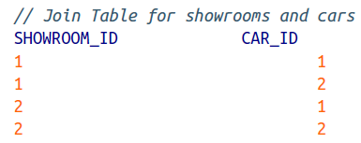

Make the following alterations to the *Showroom* entity, annotating the *cars* table as appropriate:

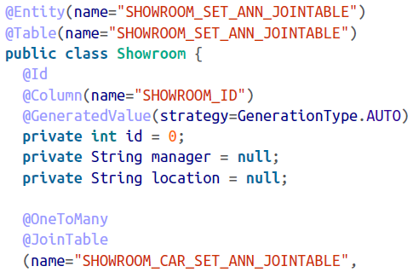

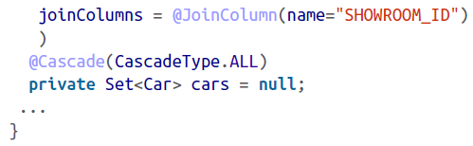

The @*JoinTable* annotation in the preceding snippet indicates that we will be using an intermediary table (SHOWROOM_CAR_SET_ANN_JOINTABLE, in this case). Also, note that cars are fetched using the SHOWROOM_ID join column.

The join table that is created is as follows:

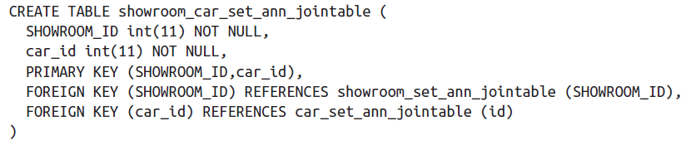

As expected, the primary key is the combination of showroom_id and car_id. Also, notice that we have defined the foreign keys from the individual tables for showroom and car.